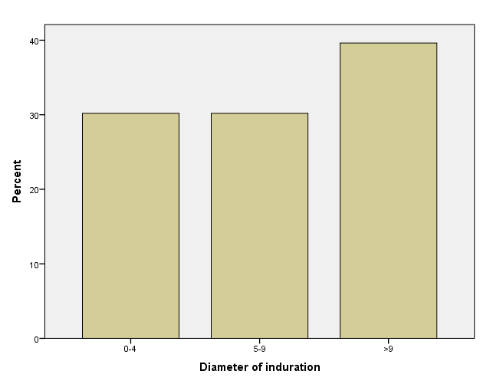

Figure 1: Distribution of the results of PPD in the first step. n=54

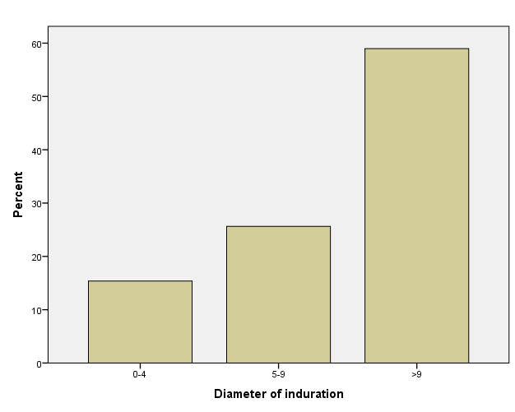

Figure 2: Distribution of the results of PPD in the third step. n=39

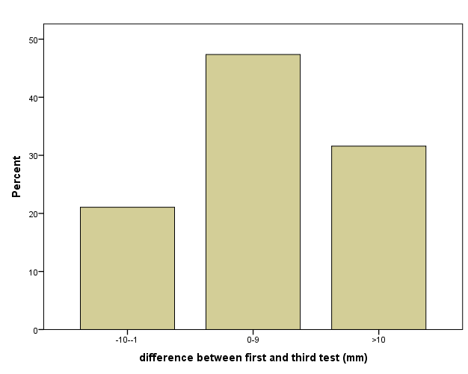

Figure 3: Pair wise differences between first and third TST (mm)

