Figure 1: Scatter plot of colony forming units (CFU) in 90mm plates in sampler and settle plates
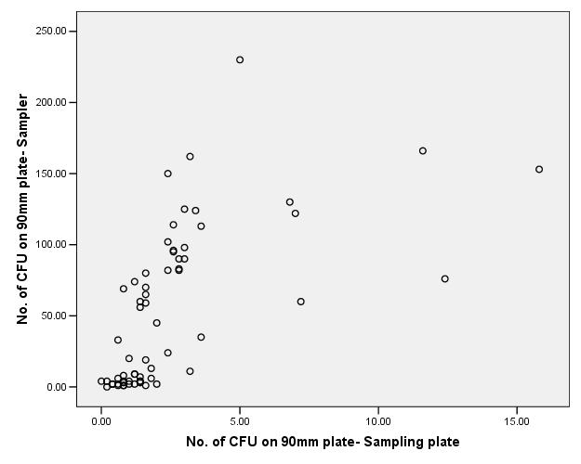
No. of CFU on 90mm plate- Settle plate

